**Four Masters National School**

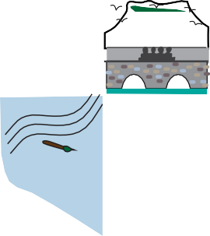

**ANNUAL ADMISSION NOTICE**

**In respect of admissions to the 2026/2027 school year**

**Admission Policy and Application Form**

|  |
| --- |
| A copy of the school’s **Admission Policy** and the **Application Form for Admission** for the 2026/2027 school year is available as follows: -  To download at: [www.fourmastersns.ie](http://www.fourmastersns.ie)  On request: By emailing [secretary@fourmastersns.ie](mailto:secretary@fourmastersns.ie) or write to: Four Masters National School, Kinlough, Co. Leitrim F91 P086 |

**Application And Decision dates for admission to 2026 / 2027 school year.**

The following are the dates applicable for admission to Junior Infants.

|  |  |
| --- | --- |
| The school will commence accepting applications for admission on | 9th September 2025 |
| The school shall cease accepting applications for admission on | 24th October 2025 |
| The date by which applicants will be notified of the decision on their application is | 28th November 2025 |
| The date by which applicants must confirm acceptance of an offer of admission is | 9th December 2025 |

**Note: the school will consider and issue decisions on late applications in accordance with the school’s admission policy.**

**\* Failure to accept and offer within the prescribed period above may result in the offer being withdrawn.**

|  |  |
| --- | --- |
| The number of places being made available in junior infants is | **45** |